**Dissecting Adversarial Attacks: A Comparative Analysis of Adversarial Perturbation Effects on Pre-Trained Deep Learning Models**

**Rekha Kumari1, Tushar Bhatia2, Peeyush Kumar Singh3, Kanishk Vikram Singh4**

**1, Assistant Professor, Department of Computer Science & Engineering, HMR Institute of Technology and management**

**2, Student, Department of Computer Science & Engineering, HMR Institute of Technology and Management**

**3, Student, Department of Computer Science & Engineering, HMR Institute of Technology and Management**

**4, Student, Department of Computer Science & Engineering, HMR Institute of Technology and Management**

**Abstract:**

**1. Introduction:**

The proliferation of neural networks across various domains has revolutionized the landscape of artificial intelligence, enabling remarkable advancements in tasks ranging from image recognition to natural language processing. Despite their widespread adoption, neural networks are not impervious to adversarial attacks—sophisticated manipulations of input data designed to deceive the model and induce misclassifications. This vulnerability has raised critical concerns about the robustness and reliability of neural network-based systems.

**1.1Neural Networks and Their Vulnerabilities:**

Neural networks, inspired by the human brain, consist of interconnected layers of nodes that process information hierarchically. Trained on vast datasets, these networks demonstrate an impressive ability to generalize patterns and make accurate predictions. However, their reliance on complex mathematical functions leaves them susceptible to adversarial perturbations—subtle alterations to input data that lead to unpredictable and often incorrect outputs.

#### **1.2The Menace of Adversarial Attacks:**

Adversarial attacks, a well-documented challenge in the field of machine learning, exploit the sensitivity of neural networks to imperceptible changes in input data. These attacks can manifest in various forms, aiming to manipulate models into making incorrect predictions. Among these, the Fast Gradient Sign Method (FGSM) stands out as a powerful and computationally efficient technique. The FGSM attack capitalizes on the gradients of a neural network's loss function to perturb input data strategically, inducing misclassifications with remarkable efficiency. Understanding and mitigating such attacks are crucial for ensuring the reliability

and security of neural network-based systems, especially in applications where erroneous decisions could have significant consequences.

#### **1.3 Significance of Evaluating Model Vulnerability:**

As neural networks continue to permeate critical domains such as healthcare, finance, and autonomous systems, ensuring their robustness against adversarial attacks becomes paramount. This research delves into the vulnerability of widely employed pre-trained deep learning models when subjected to the FGSM attack. The selected models—InceptionV3, InceptionResNetV2, ResNet152v2, Xception, DenseNet121, and MobileNet2—represent a spectrum of architectures commonly utilized in real-world applications. The inclusion of these models in our comparative analysis aims to capture a broad spectrum of responses to adversarial perturbations.

#### Brief Descriptions of Selected Models:

1. **InceptionV3:**

* + Developed by Google, InceptionV3 is renowned for its utilization of factorized convolutions, enabling efficient learning of spatial hierarchies in images. This model excels in image classification tasks and has been widely adopted in various applications.

2. **InceptionResNetV2:**

* + An extension of InceptionV3, InceptionResNetV2 integrates residual connections to enhance feature propagation. This fusion of Inception and ResNet architectures brings about improved performance in both accuracy and training speed.

3. **ResNet152v2:**

* + ResNet152v2 is part of the ResNet family, emphasizing the use of residual connections to address the vanishing gradient problem. Its depth and skip connections contribute to its efficacy in capturing intricate patterns in data.

4. **Xception:**

* + Developed by Google, Xception stands out for its focus on depth-wise separable convolutions, optimizing the trade-off between model complexity and computational efficiency. This lightweight architecture makes it particularly suitable for resource-constrained environments.

5. **DenseNet121:**

* + DenseNet121 is characterized by its densely connected blocks, fostering a tight integration of features throughout the network. This model's dense connectivity pattern contributes to enhanced feature reuse and gradient flow.

6. **MobileNetV2**

* + Tailored for mobile and edge computing, MobileNetV2 prioritizes lightweight architectures without compromising performance. Its depth-wise separable convolutions and linear bottlenecks make it a go to choice for resource-efficient applications.

**Objectives of the Study:**

Unlike traditional evaluations that focus solely on prediction accuracy, our study extends its gaze to the nuanced realm of adversarial attacks. Our objective is not merely to assess the accuracy of predictions but, more critically, to quantify the degree of perturbation required to alter the model's output label, consequently leading to misclassification. To facilitate this exploration, we have meticulously curated a 10-animal test dataset, providing a controlled environment to scrutinize how these models respond to both pristine and perturbed inputs.

Through this endeavor, we seek to unravel the intricacies of model robustness in the face of adversarial challenges. The subsequent sections of this paper detail our experimental methodology, present comprehensive results and engage in discussions that illuminate the broader implications of our findings within the dynamic landscape of deep learning and adversarial attacks.

**2. Related Works**

**[1] In "Adversarial Attacks and Defences," a research group led by Anirban Chakraborty at the Indian Institute of Technology, Kharagpur (2018) observed that Support Vector Machines (SVMs) are supervised learning models capable of constructing a hyperplane or a set of hyperplanes in high-dimensional space. SVMs can be employed for classification, regression, or outlier detection. The paper also discusses Artificial Neural Networks (ANNs), encompassing both supervised models like Convolutional Neural Networks (CNNs) and Deep Neural Networks (DNNs), as well as unsupervised network models and their associated learning rules. The study explores the vulnerability of machine learning models to adversarial attacks, presenting simple yet effective attacks on popular model classes such as logistic regression, neural networks, and decision trees. Notably, the introduction of substitute model learning is highlighted as a method to alleviate the need for attackers to infer architecture, learning models, and parameters in typical black-box attacks.**

**[2] Machine learning models, particularly neural networks, face susceptibility to adversarial examples owing to their inherently linear nature, as quantified by recent findings. Goodfellow and collaborators (2014) extensively explored this vulnerability, revealing that state-of-the-art neural network, among other models, exhibit susceptibility to adversarial perturbations. Notably, adversarial examples align closely with model weight vectors, indicating shared learning functions among diverse models. The effectiveness of adversarial training in enhancing model robustness, akin to a regularization technique exceeding dropout, was highlighted. However, Radial Basis Function (RBF) networks demonstrated resistance to adversarial and irrelevant class examples. These findings unveil inherent blind spots in training algorithms and underscore the linearity of models, prompting questions about their true understanding of assigned tasks. Goodfellow emphasized the need for optimization procedures fostering local stability in model behavior. This study consolidates prior research, affirming that adversarial training not only generates rapid adversarial examples but also provides additional regularization benefits, contributing to a nuanced understanding of the intricacies in adversarial vulnerability within machine learning models.**

**[3] The article discusses various machine learning (ML) techniques used in Intrusion Detection Systems (IDS), focusing on Deep Neural Networks (DNN), Support Vector Machines (SVM), and Generative Adversarial Networks (GAN). It highlights the role of DNN in understanding complex cyber-attacks and the efficiency of SVM with small datasets, despite their sensitivity to noise. GANs are noted for data augmentation in attack detection. Adversarial Machine Learning (AML) is explored, where adversaries create inputs to mislead ML models, emphasizing the importance of adversarial samples and attack techniques. The paper also covers adversarial game-theoretic and threat models, detailing adversaries' capabilities, challenges, and potential threats. Benchmark datasets for IDS and defense strategies against adversarial attacks are also mentioned.**

**3. Methodology**

**3.1 Data Collection and Preprocessing**

**3.1.1 Data Collection**

**We meticulously crafted a custom set of testing images to rigorously evaluate the models' performance. This set is a subset of the Animals-10 dataset, which itself is a subset of the larger ImageNet classes. The rationale behind this customization is threefold:**

**1)Close Animal Grouping:**

**The selected animals represent a group with fine-grained distinctions, challenging the models to accurately predict subtle differences between closely related classes.**

**2)Challenging Predictions:**

**By choosing animals in proximity, we aim to test the models on a more intricate task where the margin of error is smaller, demanding a higher level of precision in label prediction.**

**3)FGSM Efficacy:**

**The efficacy of the Fast Gradient Sign Method (FGSM) becomes more apparent when visualized using these carefully chosen images and labels.**

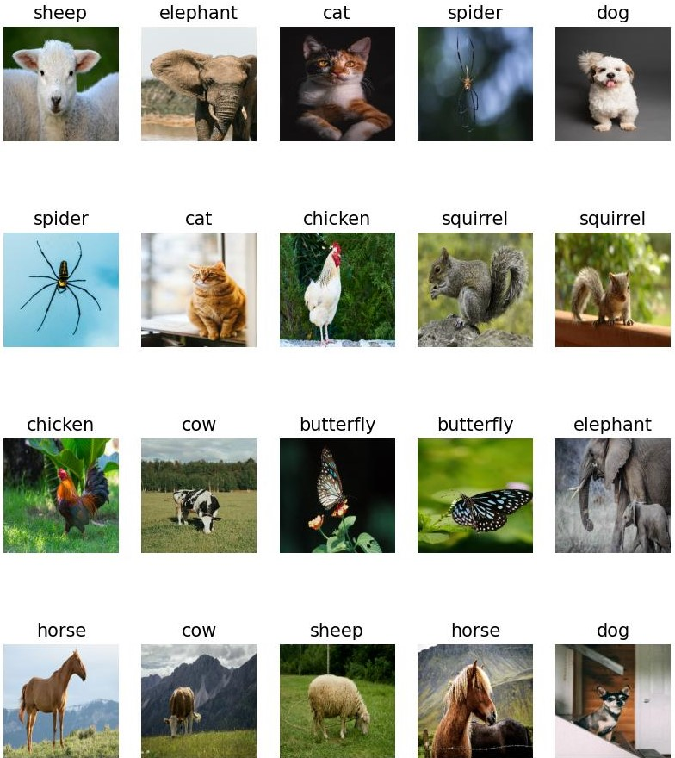

**Fig: Clean test images with their labels**

**3.1.2 Data Preprocessing**

**Normalization: All images underwent a standard normalization process to ensure consistency in model inputs. Each pixel value was normalized to the range of [-1, 1] to align with the input requirements of the models.**

**Image Resizing: To maintain uniformity, all images were resized to a standard size. While most images were resized to 224 x 224 x 3, the subset with a larger size was adjusted to 299 x 299 x 3 since the selected models have the input layer of the aforementioned sizes. This variation in image size allows us to investigate the impact of spatial information granularity on model performance.**

**3.2 Model training**

**3.2.1 Motivation for Model Building**

**The primary objective in training models from scratch was to assess the efficacy of the Fast Gradient Sign Method (FGSM) across different architectures. To achieve this, we initially constructed a set of basic classifiers with varying architectures. This preliminary phase allowed us to establish the feasibility of applying FGSM on larger pre-trained models.**

**The proposed model follows a CNN (Convolutional Neural Network) architecture. The model is implemented using the TensorFlow Keras API. The model’s architecture comprises an input layer with dimensions (224, 224, 3), followed by convolutional layers and max-pooling layers to capture hierarchical features and reduce spatial dimensions. The final layers include a flatten layer to reshape the output into a one-dimensional array and a dense layer for classification. The model is optimized using the Adam optimizer with categorical cross entropy as the loss function. The training duration is carefully chosen to ensure model convergence.**

**3.2.2 Transition to Pre-Trained Models**

**Upon confirming the suitability of FGSM through scratch-built models, we transitioned to larger, pre-trained architectures. The models selected for evaluation were Xception, ResNet152v2, Inception, InceptionResNetV2, DenseNet169, and MobileNetV2. This transition allowed us to explore FGSM across diverse complexities, providing valuable insights into model robustness and vulnerabilities.**

**3.3 Adversarial Pattern Generation**

**Adversarial Pattern Generation is a crucial component of our methodology, focusing on creating perturbations in input data to mislead neural network models. We employ the Fast Gradient Sign Method (FGSM), a well-established technique in adversarial machine learning.**

**Fast Gradient Sign Method (FGSM):**

**FGSM operates by perturbing input data based on the gradient information of the loss function with respect to the input. The perturbation is calculated to maximize the loss, leading to misclassifications. Mathematically, the perturbed image, *X(*adv)​, is generated as follows:**

***X(*adv​)=*X*+*ϵ*⋅sign(∇*X*​*J*(*X*, *Y(true)​*))**

**Here:**

**· *X* represents the clean input image.**

**· *Y(*true)​ is the true label of the clean image.**

**· *J*(*X*,*Y(*true)​) is the loss function based on the true label.**

**· ∇*X*​ denotes the gradient with respect to the input.**

**· *ϵ* controls the magnitude of perturbation.**

**The sign function ensures that the perturbation is added in the direction that increases the loss, aiming to induce misclassification. By adjusting *ϵ*, we control the strength of the attack. Smaller *ϵ* values result in subtle perturbations, while larger values lead to more pronounced changes.**

**This process is applied to each pixel in the input image, generating an adversarial image that, when fed into the neural network, is likely to be misclassified. The efficacy of FGSM lies in its simplicity and efficiency, making it a valuable tool for evaluating model robustness against adversarial attacks.**

**3.4 Pre-trained Model Evaluation**

**The Pre-trained Model Evaluation phase is a critical step in our methodology, where we assess the susceptibility of widely adopted pre-trained models to adversarial attacks using the Fast Gradient Sign Method (FGSM). We select six prominent pre-trained models for evaluation: Xception, ResNet152v2, Inception, InceptionResNetV2, DenseNet169, and MobileNetV2.**

#### **Model Initialization and Prediction on Clean Images:**

**Initially, each pre-trained model is initialized, and predictions are made on the clean images from our curated 10-animal test dataset. This step establishes a baseline for the models' performance on pristine inputs.**

#### **Tabulation and Analysis:**

**Results from the predictions on clean images are tabulated, including confidence levels and correct classifications. This tabulation provides insights into the models' initial accuracy and their behavior on the unaltered dataset.**

#### **Adversarial Generation using FGSM:**

**Next, we apply the FGSM algorithm to generate adversarial images for each model. The previously calculated gradients are utilized to perturb the input images strategically. The perturbed images, known as adversarial examples, are then created for each class in the dataset.**

#### **Testing on Perturbed Images and Comparison with Clean Ones:**

**The models are subjected to predictions on both perturbed and clean images. The predictions on adversarial examples help us evaluate the models' vulnerability to adversarial attacks. We compare these results with predictions on clean images to gauge the impact of adversarial perturbations.**

#### **Tabulation of Results, Including Epsilon Values:**

**Results from the evaluation, including confidence levels, misclassification rates, and epsilon values used for perturbations, are tabulated comprehensively. Epsilon values play a crucial role in understanding the intensity of the applied perturbations. This detailed tabulation facilitates a nuanced analysis of each model's robustness and provides a basis for comparison across different architectures.**

**This thorough evaluation process allows us to discern the resilience and vulnerabilities of pre-trained models under the FGSM attack, contributing valuable insights to the broader discourse on adversarial attacks in deep learning.**

**4. Experiments and Results**

**In this section, we meticulously detail the outcomes of our experiments, offering an in-depth examination of adversarial attacks on six prominent pre-trained deep learning models—Xception, ResNet152v2, Inception, InceptionResNetV2, DenseNet169, and MobileNetV2. Leveraging our carefully curated 10-animal test dataset, we systematically assessed the vulnerabilities of each model under the Fast Gradient Sign Method (FGSM) attack.**

**1)Xception Model**

**· Image Size: Utilizing a larger image size of 299 x 299 x 3.**

**· Epsilon Values: Predominantly low epsilon values to misclassify.**

**· Adversarial Confidence: Consistently exhibited confidence levels below 50%, indicating successful but low confidence misclassifications.**

**· Clean Input Confidence: Clean inputs displayed a mixed range of confidence levels which may explain the low epsilon value required to misclassify and low confidence of adversarial outputs.**

|  |  |  |  |
| --- | --- | --- | --- |
| **Name** | **Xception (Output and confidence)** | **Epsilon** | **Adversarial (Output and confidence)** |
| **Butterfly 1** | **Admiral: 44.27%** | **0.0132** | **Monarch: 36.92%** |
| **Butterfly 2** | **Monarch: 52.21%** | **0.0068** | **Lycaenid: 88.84%** |
| **Cat 1** | **Tiger cat: 41.97%** | **0.0075** | **Egyptian cat: 64.16%** |
| **Cat 2** | **Tiger cat: 50.24%** | **0.0475** | **Tabby: 31.53%** |
| **chicken 1** | **Cock: 89.78%** | **0.0052** | **Hen: 56.44%** |
| **chicken 2** | **Cock: 82.63%** | **0.0018** | **Hen: 42.35%** |
| **cow 1** | **Ram: 23.76%** | **0.0001** | **Ox: 21.32%** |
| **cow2** | **Ox: 48.57%** | **0.0007** | **Plow: 34.36%** |
| **dog 1** | **Lhasa: 88.00%** | **0.0023** | **Shih-Tzu: 38.75%** |
| **dog 2** | **Chihuahua: 9.12%** | **0.0012** | **German Shepherd: 4.77%** |
| **elephant 1** | **African elephant: 40.8%** | **0.0002** | **Tusker: 34.43%** |
| **elephant 2** | **African elephant: 32.51%** | **0.0002** | **Tusker: 32.27%** |
| **horse 1** | **Sorrel: 69.38%** | **0.0039** | **Hartebeest: 8.36%** |
| **horse 2** | **Sorrel: 92.67%** | **0.0062** | **Bighorn: 7.33%** |
| **sheep 1** | **Ram: 67.73%** | **0.0042** | **Ice bear: 3.70%** |
| **sheep 2** | **Ram: 93.45%** | **0.0109** | **Airedale: 4.29%** |
| **spider 1** | **Garden spider: 24.72%** | **0.0012** | **Barn spider: 15.05%** |
| **spider 2** | **Harvestman: 39.94%** | **0.9299** | **Black and gold garden spider: 29.84%** |
| **squirrel 1** | **Fox squirrel: 93.73%** | **0.0182** | **Mongoose: 7.62%** |
| **Squirrel 2** | **Fox squirrel: 94.64%** | **0.0312** | **Wood rabbit: 3.09%** |

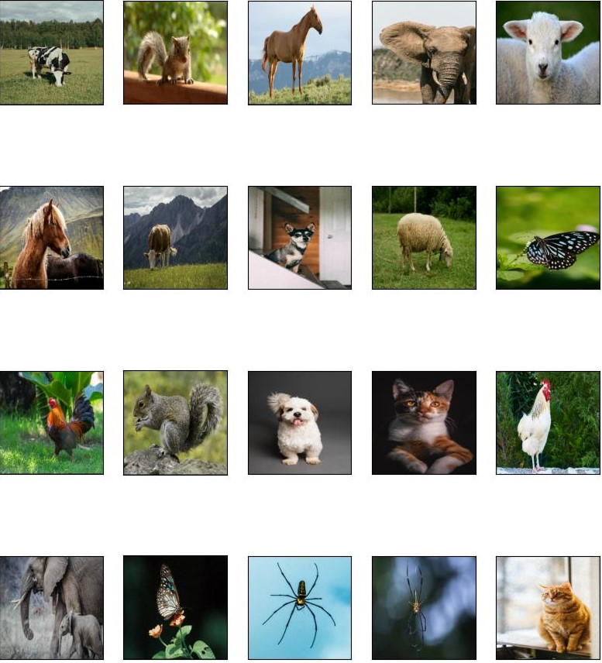

**Fig: Perturbed images of Xception model**

**2)ResNet152v2 Model**

**· Image Size: Slightly smaller image size of 224 x 224 x 3.**

**· Epsilon Values: Low epsilon values dominated for misclassification.**

**· Adversarial Confidence: Frequently achieved over 50% confidence for adversarial outputs, showing a notable weakness to perturbations.**

**· Clean Input Confidence: Clean inputs consistently demonstrated high confidence levels.**

|  |  |  |  |
| --- | --- | --- | --- |
| **Name** | **Resnet152v2 (Output and confidence)** | **Epsilon** | **Adversarial (Output and confidence)** |
| **Butterfly 1** | **Lycaenid: 99.73%** | **0.2658** | **Flatworm: 65.78%** |
| **Butterfly 2** | **Monarch: 99.99%** | **0.0240** | **Limpkin: 61.8%** |
| **Cat 1** | **Egyptian Cat: 55.66%** | **0.0089** | **Tabby: 83.54%** |
| **Cat 2** | **Tabby: 62.71%** | **0.0094** | **Tiger cat: 93.28%** |
| **chicken 1** | **Cock: 99.76%** | **0.0065** | **Hen: 53.63%** |
| **chicken 2** | **Cock: 94.32%** | **0.0079** | **Hen: 97.30%** |
| **cow 1** | **Llama: 62.78%** | **0.0058** | **Ostrich: 98.17%** |
| **cow2** | **Ox: 72.09%** | **0.0042** | **Dalmatian: 97.93%** |
| **dog 1** | **Shih-Tzu: 61.43%** | **0.0039** | **Lhasa: 98.24%** |
| **dog 2** | **Miniature pinscher: 92.77%** | **0.0048** | **Chihuahua: 99.10%** |
| **elephant 1** | **African elephant: 79.70%** | **0.0052** | **Tusker: 79.25%** |
| **elephant 2** | **African elephant: 85.76%** | **0.0069** | **Tusker: 94.53%** |
| **horse 1** | **Sorrel: 100%** | **0.0079** | **Hartebeest: 82.00%** |
| **horse 2** | **Sorrel: 99.88%** | **0.0798** | **Ibex: 54.84%** |
| **sheep 1** | **Ram: 98.41%** | **0.0081** | **Hog: 99.72%** |
| **sheep 2** | **Ram: 100%** | **0.2595** | **Komondor: 60.14%** |
| **spider 1** | **Black and gold garden spider: 80.3%** | **0.1898** | **Ant: 53.65%** |
| **spider 2** | **Black and gold garden spider: 67.23%** | **0.1288** | **Harvestman: 67.12%** |
| **squirrel 1** | **Fox squirrel: 94.01%** | **0.0028** | **Mongoose: 99.65%** |
| **Squirrel 2** | **Fox squirrel: 100%** | **0.4988** | **Porcupine: 21.93%** |

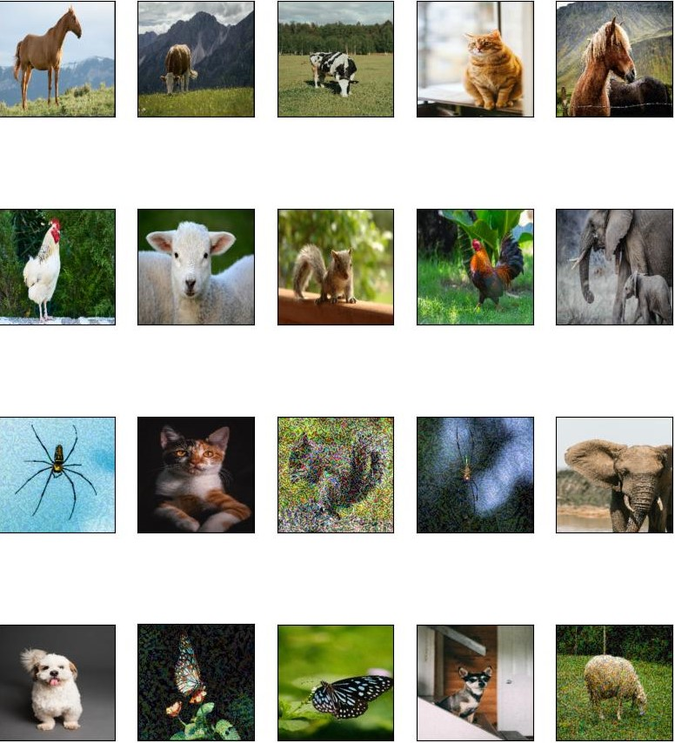

**Fig: Perturbed images of ResNet152v2 model**

**3)Inceptionv3 Model**

**· Image Size: Larger image size of 299 x 299 x 3.**

**· Epsilon Values: A preference for mostly high epsilon values (>0.1).**

**· Adversarial Confidence: The adversarial outputs predominantly registered confidence levels below 50%.**

**· Clean Input Confidence: In contrast, clean inputs consistently exhibited mixed to high confidence.**

|  |  |  |  |
| --- | --- | --- | --- |
| **Name** | **InceptionV3 (Output and confidence)** | **Epsilon** | **Adversarial (Output and confidence)** |
| **Butterfly 1** | **Monarch: 45.55%** | **0.2099** | **Mask: 4.56%** |
| **Butterfly 2** | **Monarch: 90.01%** | **0.2682** | **Lycaenid: 27.92%** |
| **Cat 1** | **Egyptian cat: 57.30%** | **0.0437** | **Tabby: 32.59%** |
| **Cat 2** | **Tiger cat: 53.30%** | **0.2564** | **Tabby: 44.63%** |
| **chicken 1** | **Cock: 83.97%** | **0.5021** | **Jigsaw puzzle: 12.21%** |
| **chicken 2** | **Cock: 93.68%** | **0.6590** | **Plastic bag: 6.55%** |
| **cow 1** | **Ox: 33.55%** | **0.0032** | **Ram: 8.24%** |
| **cow2** | **Ox: 90.06%** | **0.2830** | **Plow: 39.41%** |
| **dog 1** | **Lhasa: 79.95%** | **0.0972** | **Maltese dog: 39.38%** |
| **dog 2** | **Chihuahua: 44.04%** | **0.0037** | **Egyptian cat: 17.34%** |
| **elephant 1** | **African elephant: 54.80%** | **0.3717** | **Tusker: 13.01%** |
| **elephant 2** | **African elephant: 37.89%** | **0.4562** | **Oxygen mask: 5.93%** |
| **horse 1** | **Sorrel: 78.02%** | **0.2388** | **Airedale: 7.86%** |
| **horse 2** | **Sorrel: 81.94%** | **0.3911** | **Cougar: 21.29%** |
| **sheep 1** | **Ram: 50.66%** | **0.3658** | **Sealyham terrier: 5.76%** |
| **sheep 2** | **Ram: 89.05%** | **0.2089** | **Water buffalo: 39.20%** |
| **spider 1** | **Barn spider: 53.65%** | **0.0043** | **Garden spider: 41.03%** |
| **spider 2** | **Harvestman: 84.08%** | **0.1265** | **Barn spider: 35.78%** |
| **squirrel 1** | **Fox squirrel: 88.51%** | **0.3239** | **Grey fox: 22.77%** |
| **Squirrel 2** | **Fox squirrel: 94.73%** | **0.4688** | **Wombat: 32.47%** |

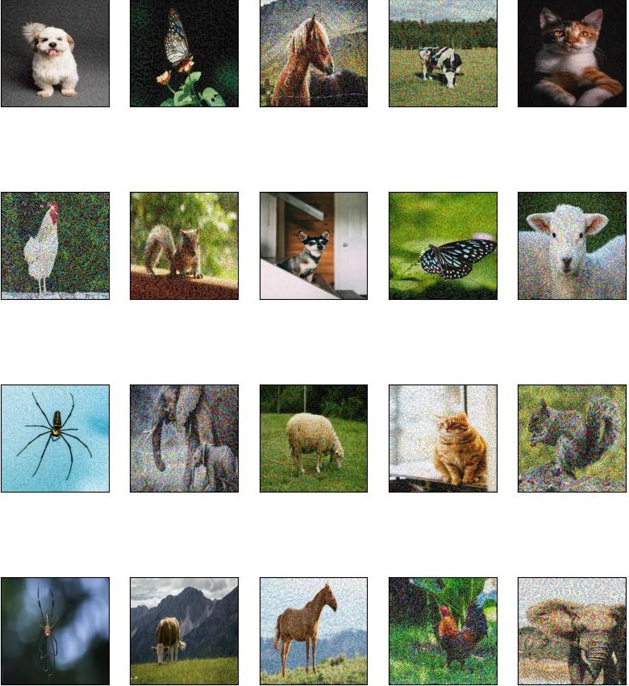

**Fig: Perturbed images of Inceptionv3 model**

**4)InceptionResNetv2 Model**

**· Image Size: Operating on the same larger image size of 299 x 299 x 3, InceptionResNetV2 showcased a deliberate exploration of perturbation space.**

**· Epsilon Values: A tendency to utilize higher epsilon values (>0.05) was noted, implying a deliberate exploration of perturbation space.**

**· Adversarial Confidence: The model primarily showcased confidence levels below 50% for adversarial outputs, indicative of successful misclassifications.**

**· Clean Input Confidence: Clean inputs consistently exhibited high confidence, showcasing the model's resilience under normal conditions.**

|  |  |  |  |
| --- | --- | --- | --- |
| **Name** | **InceptionResNetV2 (Output and confidence)** | **Epsilon** | **Adversarial (Output and confidence)** |
| **Butterfly 1** | **Lycaenid: 71.71%** | **0.0101** | **monarch 26.72%** |
| **Butterfly 2** | **Monarch: 80.37%** | **0.3853** | **puffer 12.49%** |
| **Cat 1** | **Egyptian Cat: 55.26%** | **0.0272** | **tabby 35.33%** |
| **Cat 2** | **tiger cat: 43.28%** | **0.0760** | **tabby 29.40%** |
| **chicken 1** | **Cock: 92.40%** | **0.7364** | **Goldfish: 7.57%** |
| **chicken 2** | **Cock: 86.61%** | **0.9087** | **Hen: 17.73%** |
| **cow 1** | **Ox: 70.80%** | **0.0132** | **water buffalo: 46.16%** |
| **cow2** | **Ox: 92.55%** | **0.0885** | **Plow: 35.58%** |
| **dog 1** | **Lhasa: 56.52%** | **0.0958** | **Maltese dog: 31.23%** |
| **dog 2** | **Chihuahua: 87.34%** | **0.2923** | **Miniature pinscher: 46.57%** |
| **elephant 1** | **African elephant: 78.50%** | **0.2573** | **Tusker: 44.91%** |
| **elephant 2** | **African elephant: 62.37%** | **0.3221** | **Tusker: 44.47%** |
| **horse 1** | **Sorrel: 92.32%** | **0.0584** | **Hartebeest: 39.66%** |
| **horse 2** | **Sorrel: 90.94%** | **0.0553** | **Basenji: 5.92%** |
| **sheep 1** | **Ram: 86.40%** | **0.5832** | **Hog: 31.57%** |
| **sheep 2** | **Ram: 90.88%** | **0.3273** | **Armadillo: 39.76%** |
| **spider 1** | **Garden spider: 29.96%** | **0.0095** | **Black widow: 21.75%** |
| **spider 2** | **Harvestman: 89.01%** | **0.3939** | **Garden spider: 20.54%** |
| **squirrel 1** | **Fox squirrel: 89.42%** | **0.5089** | **Grey fox: 33.67%** |
| **Squirrel 2** | **Fox squirrel: 94.45%** | **0.3694** | **Mongoose: 11.66%** |

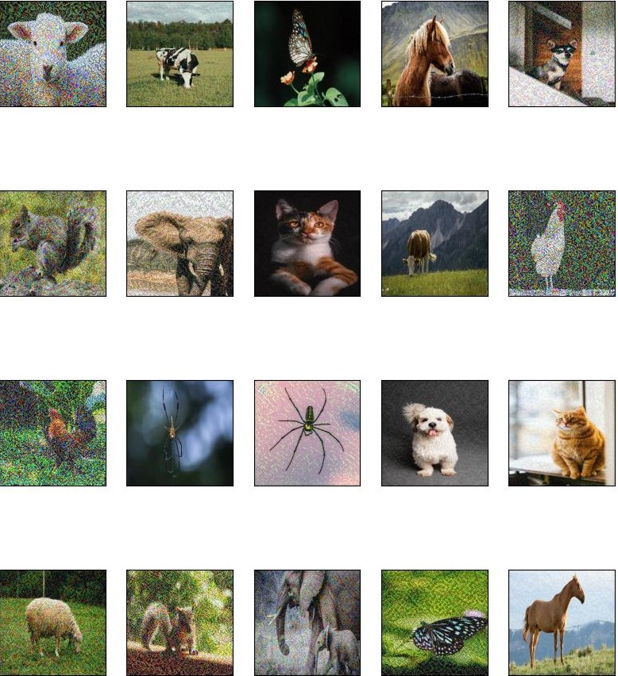

**Fig: Perturbed images of InceptionResNetv2 model**

**5)DenseNet169 Model**

**· Image Size: Smaller image size of 224 x 224 x 3.**

**· Epsilon Values: Low epsilon values were observed.**

**· Adversarial Confidence: Mostly registered confidence levels below 50%.**

**· Clean Input Confidence: Displayed a mixed range of confidence levels.**

|  |  |  |  |
| --- | --- | --- | --- |
| **Name** | **Densenet169 (Output and confidence)** | **Epsilon** | **Adversarial (Output and confidence)** |
| **Butterfly1** | **Lycaenid: 33.29%** | **0.0001** | **Monarch:26.95%** |
| **Butterfly2** | **Monarch: 86.55%** | **0.0249** | **Lycaenid: 40.66%** |
| **Cat1** | **Tiger cat: 39.02%** | **0.0134** | **Egyptian cat:30.02%** |
| **Cat2** | **Tiger cat: 54.85%** | **0.0014** | **Screen: 17.26%** |
| **chicken1** | **Cock: 93.21%** | **0.0039** | **Hen: 50.15%** |
| **chicken2** | **Cock: 98.65%** | **0.0031** | **Hen: 51.10%** |
| **cow1** | **Ram: 42.49%** | **0.0012** | **Bighorn: 19.3%** |
| **cow2** | **Dalmatian: 53.29%** | **0.0003** | **Ox:42.61%** |
| **dog1** | **Lhasa: 64.37%** | **0.0005** | **Shih-Tzu: 44.5%** |
| **dog2** | **Cardigan:25.32%** | **0.0001** | **Miniature_pinscher:26.15%** |
| **elephant1** | **African elephant:49.76%** | **0.0004** | **Tusker:41.27%** |
| **elephant2** | **African elephant:73.92%** | **0.0018** | **Tusker:41.42%** |
| **horse1** | **Sorrel:56.41%** | **0.0003** | **Hartebeest:43.01%** |
| **horse2** | **Sorrel:43.92%** | **0.0006** | **Ram:26.73%** |
| **sheep1** | **Ram:91.75%** | **0.0014** | **Wallaby:46.23%** |
| **sheep2** | **Ram:73.58%** | **0.0022** | **Komondor:26.84%** |
| **spider1** | **Garden spider:51.34%** | **0.0011** | **Black and gold garden spider:31.1%** |
| **spider2** | **Harvestman:43.57%** | **0.0003** | **Black and gold garden spider:30.96%** |
| **squirrel1** | **Fox squirrel: 92.61%** | **0.0017** | **Mongoose:48.48%** |
| **squirrel2** | **Fox squirrel: 99.79%** | **0.0068** | **Marmot:46.23%** |

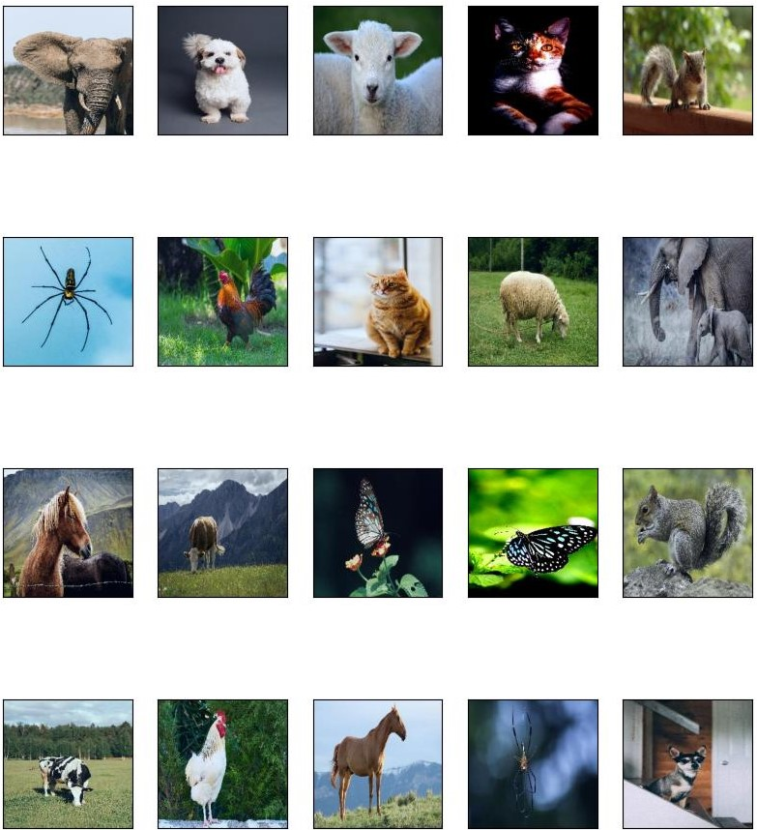

**Fig: Perturbed images of DenseNet169 model**

**6)MobileNetv2 Model**

**· Image Size: Smaller image size of 224 x 224 x 3.**

**· Epsilon Values: Mostly low epsilon values.**

**· Adversarial Confidence: The adversarial outputs consistently exhibited confidence levels below 50%.**

**· Clean Input Confidence: Clean inputs showcased a mixed range of confidence levels.**

|  |  |  |  |
| --- | --- | --- | --- |
| **Name** | **MobilenetV2 (Output and confidence)** | **Epsilon** | **Adversarial (Output and confidence)** |
| **Butterfly1** | **Lycaenid: 86.27%** | **0.0011** | **Admiral :29.7%** |
| **Butterfly2** | **Lycaenid:19.19%** | **0.0003** | **Monarch :14.18%** |
| **Cat1** | **Tiger cat :25.11%** | **0.0003** | **Egyptian cat :24.09%** |
| **Cat2** | **Tiger cat :76.59%** | **0.0023** | **Laptop :16.19%** |
| **chicken1** | **Cock :81.73%** | **0.0065** | **Hen :13.04%** |
| **chicken2** | **Cock :72.72%** | **0.0008** | **Hen :49.44%** |
| **cow1** | **Ram :34.08%** | **0.0002** | **Ox :25.61%** |
| **cow2** | **Ox :20.3%** | **0.0003** | **Dalmatian :15.72%** |
| **dog1** | **Shih-tzu :70.03%** | **0.0012** | **Lhasa :29.56%** |
| **dog2** | **Egyptian cat :22.19%** | **0.0003** | **Carton :11.97%** |
| **elephant1** | **African elephant :79.3%** | **0.0009** | **Tusker :45.96%** |
| **elephant2** | **African elephant :70.03%** | **0.0012** | **Tusker :25.61%** |
| **horse1** | **Sorrel :38.39%** | **0.0006** | **Saluki :13.15%** |
| **horse2** | **Sorrel :38.43%** | **0.0008** | **brown bear :15.81%** |
| **sheep1** | **Ram :62.41%** | **0.0014** | **Hog :8.59%** |
| **sheep2** | **Ram :97.07%** | **0.0099** | **Hay :12.88%** |
| **spider1** | **Garden spider :45.12%** | **0.0007** | **Black and gold spider :28.03%** |
| **spider2** | **Garden spider :49.43%** | **0.0004** | **Black and gold spider :40.46%** |
| **squirrel1** | **Fox squirrel :80.7%** | **0.0038** | **Egyptian cat :7.67%** |
| **squirrel2** | **Fox squirrel :94.78%** | **0.00399** | **grey fox :8.49%** |

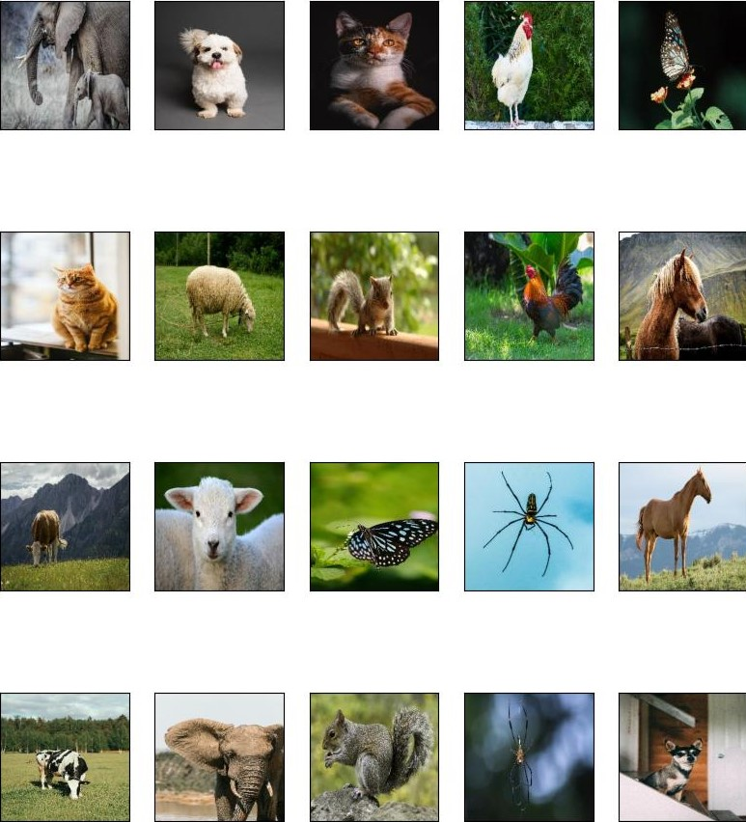

**Fig: Perturbed images of MobileNetv2 model**

|  |  |  |  |  |
| --- | --- | --- | --- | --- |
| **Model** | **Image Size** | **Epsilon Values** | **Adversarial Confidence (in %)** | **Clean Input Confidence** |
| **Xception** | **299 x 299 x 3** | **Low** | **<50%** | **Mixed** |
| **ResNet152v2** | **224 x 224 x 3** | **Low** | **>50%** | **Mixed** |
| **Inception** | **299 x 299 x 3** | **High** | **<50%** | **High** |
| **InceptionResNetv2** | **299 x 299 x 3** | **High** | **<50%** | **High** |
| **DenseNet169** | **224 x 224 x 3** | **Low** | **<50%** | **Mixed** |
| **MobileNetv2** | **224 x 224 x 3** | **Low** | **<50%** | **Mixed** |

**5. Conclusion and Future Scope**

**In the realm of deep learning, our investigation into adversarial vulnerabilities within pre-trained models has revealed compelling insights. The scrutiny of six prominent models—Xception, ResNet152v2, Inception, InceptionResNetV2, DenseNet169, and MobileNetV2—under the Fast Gradient Sign Method (FGSM) attack has provided a nuanced understanding of their response to adversarial perturbations. Noteworthy findings include-**

* **The pre-trained models are susceptible to adversarial attacks such as FGSM.**
* **Some models notably Inception and InceptionResNetv2 demonstrated more resistance to FGSM as evident by the high epsilon values required to misclassify.**
* **Some models notably Xception, DenseNet169 and MobileNetv2 misclassified at low epsilon values but their degree of classification i.e. the output confidence was notably lower.**
* **The ResNet152v2 started misclassifying at low epsilon values with high confidence.**
* **The models that have high confidence for clean images resist FGSM to a greater degree than those who have low confidence for clean images.**
* **It is also seen that the model which takes the larger image size as input resists the FGSM to a greater degree than those who take smaller image size as input. This may be due to the fact that a larger size image has much more pixels for the model to consider while making an inference and thus require a greater amount of change in the image to misclassify.**

**This study extends beyond conventional accuracy assessments, offering a detailed analysis of perturbation impacts on model outputs. The inclusion of epsilon values and confidence levels enhances the depth of our evaluation, setting a valuable benchmark for future research in adversarial robustness. By shedding light on the intricate interplay between model architecture and adversarial attacks, our work contributes to a more holistic understanding of model vulnerabilities.**

**As the field of adversarial machine learning continues to evolve, several promising avenues beckon for future exploration. The investigation of adversarial example transferability across diverse models and architectures holds the potential to unveil broader patterns in vulnerability. Real-world applications, particularly in domains like healthcare and autonomous systems, present intriguing challenges for mitigating adversarial impact. Future research endeavors may delve into the integration of defense mechanisms and robust training strategies to fortify models against adversarial threats. This study serves as a stepping stone, urging the research community to delve deeper into fortifying artificial intelligence against the ever-evolving landscape of adversarial challenges.**

**6. References**